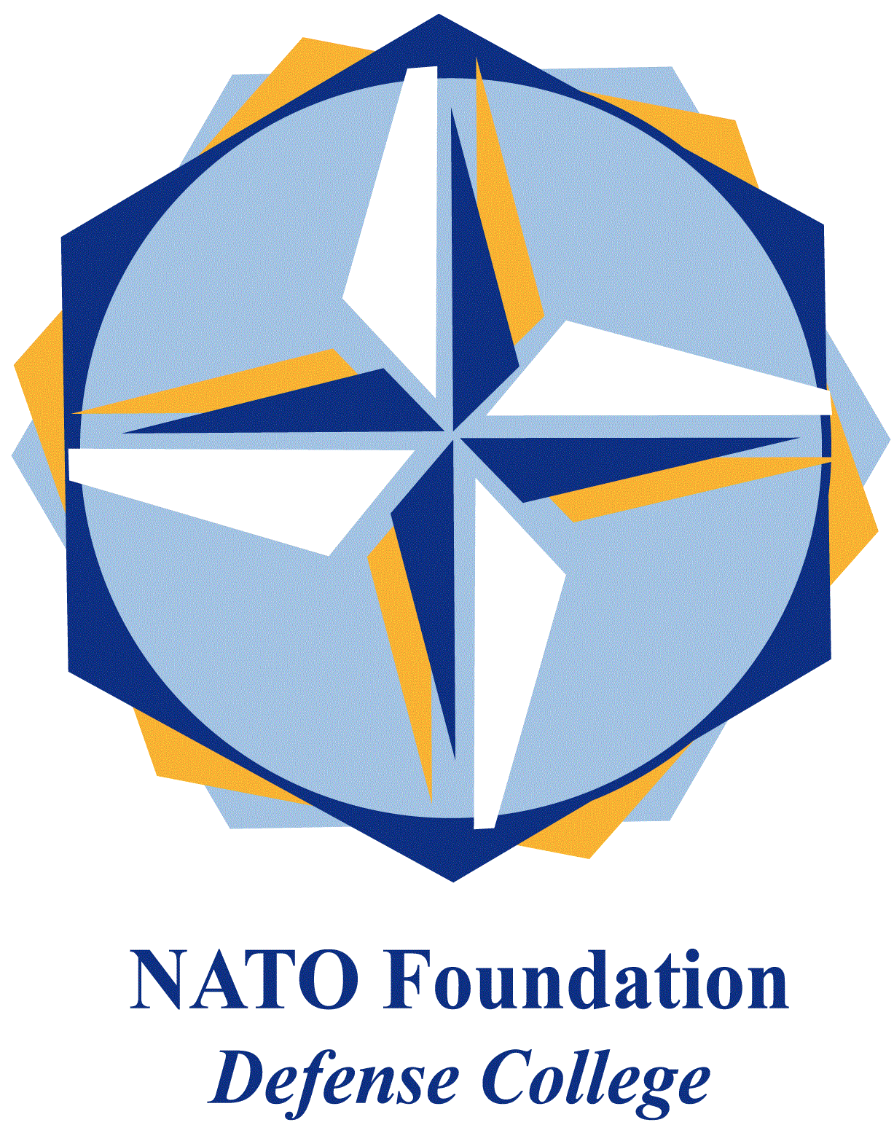
NATO DEFENSE COLLEGE FOUNDATION
STRATEGIC TRENDS
March 2016
MAGHREB
AQIM’s innovative comeback in Algeria
On 18th March 2016 mortar shells fell on the Krechba gas treatment plant in Ghardaïa wilaya, central Algeria. The attack, which caused no victims or major damages, was claimed by al-Qaeda in the Islamic Maghreb (AQIM), the North African branch of al-Qaeda central. Apparently sidelined by the rise of the Islamic State (IS) terrorist organization in Middle East and North Africa, AQIM’s comeback in Algeria showed the strength of the group, its increasing capabilities and a more complex strategy.
The attack occurred in the Ain Salah shale gas field. Last year protests erupted in several towns in Algeria against the development of shale gas, forcing the Prime Minister Abdelmalek Sellal to announce the postponement of the drilling in the areas concerned. Echoing these demonstrations, AQIM’s statement warned Western companies of entering Algeria, profiting from the country’s resources and causing environmental damages by recurring to the hydraulic fracturing techniques.
AQIM’s reference to the shale gas stresses the organization’s willingness to win the support of local people, condemning the Western presence in the country. Moreover, the group stated that the attack was only intimidating and that they warned the oil companies of the imminent attack, in order not to harm any Muslim worker. However, it is likely that the strong defence perimeter around the plant forced the group to fire from a long distance, missing the target.
The Algerian army did not confirm press reports about the killing of four terrorists near the plant in the following days. Despite contrasting versions about the authors of the attack (locals or a group from abroad), AQIM’s increasing activity in the Maghreb-Sahel region must not be underestimated. Three days later an attack against the EU training mission in Bamako, Mali, was claimed by AQIM. Security forces repelled the attack and one assailant was shot dead.
The recent string of attacks in West Africa substantiate AQIM’s new offensive drive. On the 13th of March the organization claimed the shooting at the Grand-Bassam beach resort in Ivory Coast that caused 18 victims and 33 injured. On 15th January AQIM claimed an attack against hotels in Ougadougou, Burkina Faso, where 30 people died and more than 50 were injured. On 15th November an attack against a hotel in central Bamako, Mali, caused more than 20 victims.
All these attacks are part of a more complex expansion project, intended to respond to Daesh’s increasing appeal in the region. AQIM adopted a more diversified strategy: beside traditional targets, like security forces or critical infrastructures, the organization is now interested in soft targets like hotels and beach resorts, in order to maximise casualties.
Furthermore, the attacks in Mali and Burkina Faso were claimed by al-Mourabitoun, an offshoot of AQIM led by Algerian national Mokhtar Belmokhtar. The group claimed responsibility for the attack against the Tiguentourine gas field in In Amenas, Algeria, and the following hostage crisis that caused more than 40 dead in January 2013.
After a long spat between the Belmokhtar and AQIM’s leader Abdelmalek Droukdel, last year al-Mourabitoun announced that it was rejoining AQIM. The move was intended to dismiss the rumours about a supposed al-Mourabitoun’s act of allegiance to IS. At the same time AQIM is taking advantage of the alliance: considered in decline, the Maghreb branch of al-Qaeda can now rely on al-Mourabitoun extensive terrorist network in the region, including safe havens, arms caches and financing through illicit trafficking and smuggling. In the short-term it is likely that further attacks will occur in the region, in order to show the group’s reactiveness to IS’ expansion in the area.

